**BEFORE THE ENVIRONMENTAL APPEALS BOARD UNITED STATES ENVIRONMENTAL PROTECTION AGENCY WASHINGTON, D.C.**

InRe:

Government of the District of Columbia

Municipal Separate Storm Sewer System

NPDES Permit No. DC 0000221

)

)

)

) NPDES Appeal Nos. 11-05 and 11-06

)

)

)

**ENVIRONMENTAL PROTECTION AGENCY REGION III'S NOTICE OF PROPOSED MODIFICATION TO PERMIT**

The U.S. Environmental Protection Agency Region III ("EPA Region III"), by and through the undersigned counsel, hereby submits to the Environmental Appeals Board ("EAB" or "Board") the following Notice, pursuant to 40 C.F.R. § 124.19, of its proposed modification to

the District of Columbia Municipal Separate Storm Sewer System Permit.

**BACKGROUND**

On September 30,2011, EPA Region III issued a final Phase I Municipal Separate Storm Sewer System ("MS4") NPDES permit (Permit No. DC0000221) to the Government of the District of Columbia ("DC Government" or "the Permittee"), which had an effective date of October 7, 2011 ("the DC MS4 Permit"). The sole permittee of the DC MS4 Permit is the DC Government. *See, e.g.,* DC MS4 Permit at p.1 (cover sheet), Section 2.3.1.

On November 4, 2011, DC Water and the Wet Weather Partnership jointly filed a petition requesting that the EAB review the DC MS4 Permit. Four environmental groups- Friends of the Earth, the National Resources Defense Council, the Anacostia Riverkeeper, and the Potomac

Riverkeeper (collectively, the "Environmental Petitioners")- also jointly filed a petition for review on November 4, 2011. On November 17, 2011, DDOE requested leave to intervene and to respond to the petitions. The Board granted DDOE's request in its February 2, 2012 Order.

By way of Orders dated February 14,2012 and April 11, 2012, the Board temporarily stayed proceedings on the Petition to allow for participation in the Board's Alternative Dispute Resolution pilot process. On May 8, 2012, the Board lifted that stay for Petition 11-05. Petition

11-06 continues to be stayed to allow for implementation of a settlement agreement between the Environmental Petitioners and EPA Region III dated May 18,2012 *(see* Order Continuing Stay ofProceedings (May 22, 2012)).

**DISCUSSION**

Today, July 12,2012, EPA Region III made available for public notice and comment limited draft modifications to the Permit, made pursuant to 40 C.P.R.§ 124.19, 40 C.P.R.§

122.62 and 40 C.P.R.§ 122.63. Those draft modifications are proceeding through the same process of public comment and opportunity for a public hearing as would apply to any other draft permit. Specifically, public notice has been given via publication of a notice in the *Washington*

*Times* (see Exhibit A)1 and via website (see Exhibit Bf

The draft modification (Exhibit C), the accompanying draft fact sheet (Exhibit D), and the accompanying administrative record (index attached as Exhibit E) are available for viewing at EPA Region III (1650 Arch Street, Philadelphia, PA 19103) and at the Martin Luther King, Jr.

1 Also available at [http://www.print2webcorp.com/marketplace/washingtontimes/main/AdvancedSearch.aspx?11=Legal+Notices&l2=&](http://www.print2webcorp.com/marketplace/washingtontimes/main/AdvancedSearch.aspx?11=Legal%2BNotices&amp;l2) Categories=Legal+Notices&r=O&keys=Environmental+Protection+Agency&t= l %2C2%2C3&op=O&em=&search.x

=3l&search.y=6

2 Also available at [http://www.epa.gov/reg3wapd/public_notices.htm.](http://www.epa.gov/reg3wapd/public_notices.htm)

2

Public Library located at 901 G Street N.W., Washington, DC 20001. Any portions of the permit not withdrawn and/or modified and not stayed under 124.16(a) continue to apply. Comments

will be accepted for a period of forty-five (45) days, closing on August 27, 2012.

**CONCLUSION**

For the reasons discussed above, EPA respectfully requests that the Board accept this Notice of

EPA's proposed modification to the Permit.

Respectfully submitted this 12th day of July, 2012.

For Respondent:

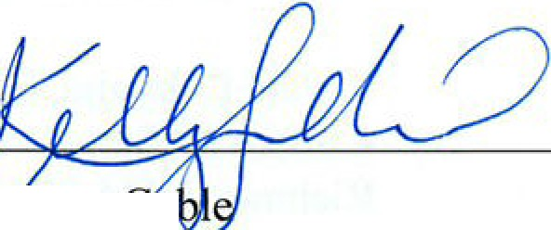

Kel y A. a

Assistant Regional Counsel (3RC20) EPA Region III

1650 Arch Street Philadelphia, PA 19103 (215) 814-2471 [gable.kelly@epa.gov](mailto:gable.kelly@epa.gov)

Sylvia Horwitz

U.S. EPA Office ofGeneral Counsel (2355A) Ariel Rios North Room 7353H

1200 Pennsylvania Ave., N.W. Washington, DC 20460

(202) 564-5511

*Of Counsel*

Dated: July 12, 2012

3

CERTIFICATE OF SERVICE

I hereby certify that on the date indicated below I filed the original *Notice of Proposed Modification to Permit* with the Clerk of the Environmental Appeals Board electronically through the CDX System. I also hereby certify that, on the same date, I sent a hard copy of the foregoing document to each of the parties below via First Class mail:

Jennifer C. Chavez, Esq. Earthjustice Legal Defense Fund

1625 Massachusetts Ave., N.W., Suite 702

Washington, D.C. 20036

Rebecca J. Hammer, Esq.

Natural Resources Defense Council

1152 15th Street, N.W., Suite 300

Washington, D.C. 20005

F. Paul Calamita, Esq.

. 6 South 5th Street

Richmond, VA 23219

Randy Hayman, General Counsel Gregory Hope, Principal Counsel DC Water

5000 Overlook Ave., S.W. Washington, D.C. 20032

Amy E. McDonnell, Esq. Alan Barak, Esq.

Office of the Attorney General

District Department of the Environment

1200 First St. N.E., ih Floor

Washington, D.C. 20002

Dated:__L._ rt. oz" ' J-4" "'= -....l;_.:l...-/

ly A.

Assistan ional Counsel (3RC20) EPA Region III

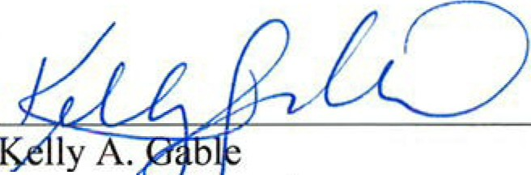

1650 Arch Street Philadelphia, PA 19103 (215) 814-2471 [gable.kelly@epa.gov](mailto:gable.kelly@epa.gov)